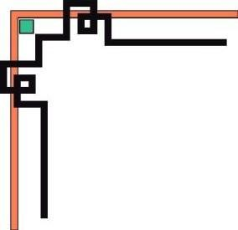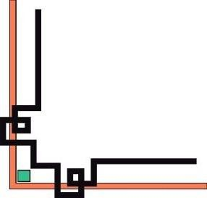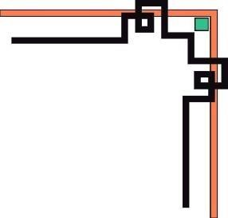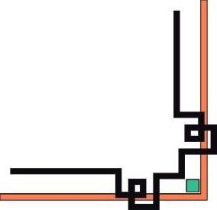

**KHOA ĐÀO TẠO QUỐC TẾ**

**----------**

**FINAL REPORT**

**\*\*\***

DESIGN AND IMPLEMENT A MAZE GAME USING AI ALGORITHMS

**MÃ MÔN HỌC:** DASA230179E\_02FIE

**GRADE:** Monday, period 3-5

# STUDENT PERFORMENT:

|  |  |  |
| --- | --- | --- |
| **Full name** | **Student ID** | **Contribution** |
| Đỗ Huỳnh Bảo Đăng | 21110764 | 100% |
| Nguyễn Duy Mạnh | 21110780 | 100% |
| Đỗ Xuân Trường | 21110101 | 100% |

**LECTURER:** PGS.TS. Hoàng Văn Dũng

Ho Chi Minh City, November 28, 2023

# LIST OF MEMBERS INVOLVED IN WRITING REPORTS

|  |  |  |  |
| --- | --- | --- | --- |
| **NUM** | **FULL NAME** | **STUDENT ID** | **COMPLETION** |
| 1 | Đỗ Huỳnh Bảo Đăng | 21110764 | 100% |
| 2 | Nguyễn Duy Mạnh | 21110780 | 100% |
| 3 | Đỗ Xuân Trường | 21110101 | 100% |

Note:

* Percentage = 100%: The percentage level of each student participating.
* Leader: Đỗ Huỳnh Bảo Đăng

***Lecturer reviews***

…………………………………………………………………………………….

…………………………………………………………………………………….

…………………………………………………………………………………….

…………………………………………………………………………………….

*28/11/2023*

Score

(Signature of lecturer)

Hoàng Văn Dũng

**LIST OF ABBREVIATIONS**

|  |  |
| --- | --- |
| BFS | Breadth first search |
| DFS | Depth-First Search |
| GBFS | Greedy best first search |

# THANKS

For successfully completing this project and report, we would like to express our sincere thanks to the lecturer, Associate Professor Dr. Hoang Van Dung, who directly supported us during the working process. We thank you for giving us advice from our practical experience to guide us in accordance with the requirements of the chosen topic, always answering questions and giving suggestions and corrections in time to help us overcome our weaknesses and complete well as on time.

We would also like to sincerely thank the teachers in the Faculty of International Education in general and the Information Technology industry in particular for their dedication to imparting the necessary knowledge to help us have the foundation to make this topic, for creating conditions for us to learn and implement the topic well. Along with that, we would like to thank our classmates for providing a lot of useful information and knowledge to help us improve our topic.

The topic and report are carried out in a short period of time, with limited knowledge and many other limitations in terms of technique and experience in implementing a software project. Therefore, in the process of creating the topic, there are inevitable shortcomings, so we look forward to receiving valuable comments from teachers so that our knowledge is improved and we can do better in the next time. We sincerely thank you

Finally, we wish you good health and success in your career. Once again we would like to sincerely thank you.

Ho Chi Minh City, November 28, 2023

Đỗ Huỳnh Bảo Đăng

Nguyễn Duy Mạnh

Đỗ Xuân Trường

# INDEX

# 

[STUDENT PERFORMENT: 1](#_Toc13647)

[LIST OF MEMBERS INVOLVED IN WRITING REPORTS 2](#_Toc4037)

[THANKS 2](#_Toc22324)

[INDEX 3](#_Toc19550)

[1. INTRODUCTION 7](#_Toc23214)

[1.1 Reason for choice: 7](#_Toc13765)

[1.2 Statement of the problem: 7](#_Toc25623)

[1.3 Purpose and requirements to be fulfilled: 7](#_Toc25935)

[1.4 Scope and objects: 7](#_Toc7246)

[2. THEORETICAL BASIS 7](#_Toc27085)

[2.1 Programming environment 7](#_Toc645)

[2.2 Support library 8](#_Toc27311)

[2.3 Basic theory of AI algorithms 8](#_Toc14700)

[2.3.1 Breadth first search (BFS): 8](#_Toc7414)

[2.3.2 Depth first search (DFS): 8](#_Toc4807)

[2.3.3 Astar: 8](#_Toc24821)

[2.3.4 Dijkstra’algorithm: 9](#_Toc29881)

[2.3.5 Greedy best first search algorithm: 9](#_Toc22266)

[3. IMPLEMENTATION PLAN 10](#_Toc20029)

[3.1 Plan 10](#_Toc27216)

[3.2 Task 10](#_Toc15535)

[4. IDEA, INTERFACE, ALGORITHM OF THE PROBLEM. 11](#_Toc3387)

[4.1 Idea 11](#_Toc21072)

[4.2 GUI 11](#_Toc30166)

[4.2.1 Create Map 11](#_Toc11812)

[4.2.2 Create Map 13](#_Toc27102)

[4.2.3 Create a goal position 13](#_Toc9504)

[4.3 Algorithm 14](#_Toc28442)

[4.3.1 BFS Algorithm 14](#_Toc27038)

[4.3.1.1 Idea 14](#_Toc19882)

[4.3.1.2 Description in Python 15](#_Toc612)

[4.3.2 DFS Algorithm 16](#_Toc12788)

[4.3.2.1 Idea 17](#_Toc13898)

[4.3.2.2 Description in Python 17](#_Toc30827)

[4.3.3 A\* Algorithm 19](#_Toc27661)

[4.3.3.1 Idea 19](#_Toc11459)

[4.3.3.2 Description in Python 19](#_Toc31420)

[4.3.4 Greedy Best-First Search Algorithm 22](#_Toc30637)

[4.3.4.1 Idea 22](#_Toc18103)

[4.3.4.2 Description in Python 23](#_Toc22710)

[4.3.5 Dijkstra's Algorithm 25](#_Toc29528)

[4.3.5.1 Idea 25](#_Toc1986)

[4.3.5.2 Description in Python 26](#_Toc23299)

[5. FUNCTION. 28](#_Toc14198)

[5.1 Player function 28](#_Toc18540)

[5.2 Bot function 28](#_Toc26572)

[5.3 Bot vs Bot 29](#_Toc854)

[5.4 Player vs Player 30](#_Toc12901)

[6. EXPERIMENT, ANALYZE, EVALUATE RESULTS. 32](#_Toc5155)

[6.1 Interface information 32](#_Toc1624)

[6.1.1. Interface when starting the game 32](#_Toc31965)

[6.1.2. Interface 4 goals and 3 mazes 32](#_Toc23467)

[6.1.3. Start Node (Player) 34](#_Toc8926)

[6.1.4. Start Node (Bot) 34](#_Toc9110)

[6.1.5. Game mode 35](#_Toc2289)

[6.2. Analyze, experiment, evaluate 36](#_Toc10623)

[6.2.1. Analyze, experiment 36](#_Toc26208)

[6.3. Summary table 38](#_Toc6701)

[7. CONCLUSION. 40](#_Toc9342)

[7.1 Assessments: 40](#_Toc10635)

[7.2 Development: 40](#_Toc5202)

[7.3 Experience learned: 40](#_Toc29797)

[8. REFERENCES. 41](#_Toc2151)

[8.1. How to Make a Maze Game in Python - Python Code (thepythoncode.com) 41](#_Toc12127)

[8.2. A\* Search Algorithm - GeeksforGeeks 41](#_Toc21108)

[8.3. Breadth First Search or BFS for a Graph - GeeksforGeeks 41](#_Toc7786)

[8.4. Depth First Search or DFS for a Graph - GeeksforGeeks 41](#_Toc25426)

[8.5. C / C++ Program for Dijkstra's shortest path algorithm | Greedy Algo-7 - GeeksforGeeks 41](#_Toc236)

[8.6. Greedy Best first search algorithm - GeeksforGeeks 41](#_Toc28440)

**LIST OF FIGURES**

***[Figure 1: excel.csv](#_Toc21672)* [13](#_Toc21672)**

***[Figure 2: Interface for maze](#_Toc1865)* [15](#_Toc1865)**

***[Figure 3: Flowchart of BFS algorithm](#_Toc17612)* [18](#_Toc17612)**

***[Figure 8: Interface when starting the game](#_Toc23556)* [37](#_Toc23556)**

***[Figure 9: Interface for 4 goals](#_Toc26554)* [38](#_Toc26554)**

***[Figure 10: Interface for 3 mazes](#_Toc13788)* [39](#_Toc13788)**

***[Figure 11: Interface for running bot](#_Toc7320)* [40](#_Toc7320)**

***[Figure 12: Interface for 2 players](#_Toc17963)* [40](#_Toc17963)**

***[Figure 13: Interface for two bots](#_Toc31883)* [41](#_Toc31883)**

***[Figure 14: Interface for BFS](#_Toc6869)* [41](#_Toc6869)**

***[Figure 15: Interface for DFS](#_Toc11174)* [42](#_Toc11174)**

***[Figure 16: Interface for A Star](#_Toc26199)* [42](#_Toc26199)**

***[Figure 17: Interface for GBFS](#_Toc7749)* [43](#_Toc7749)**

***[Figure 18: Interface for Dijkistra](#_Toc28713)* [43](#_Toc28713)**

1. **INTRODUCTION**
   1. **Reason for choice:**

**-** Maze game are relatively simple game, making them suitable for a focused AI project. The confined nature of mazes allows students to concentrate on fundamental AI concepts without being overwhelmed by unnecessary complexity

**-** Maze solving is a classic problem that involves search algorithms. Implementing algorithms like depth-first search, breadth-first search, A\* search, or other heuristic-based approaches allows us to understand and experiment with fundamental AI search techniques.

**1.2 Statement of the problem:**

The specific problem is to use algorithms learned in artificial intelligence to decode a maze and find the way to the treasure location.

**1.3 Purpose and requirements to be fulfilled:**

The purpose of this topic is to use a visual interface to describe the process of decoding the algorithms AStar, Breadth first search, Depth first search, Dijkstra’algorithm, Greedy best first search algorithm and calculate the execution time of each algorithm. for each different state space.

**1.4 Scope and objects:**

The problem of finding a path in a maze is used to simulate and evaluate algorithms in decoding different mazes, thereby making comments and conclusions about decoding the maze and evaluating the state space. as well as calculate the algorithm execution time to determine for each different state space, which algorithm we need to use to optimize as much as possible.

This large exercise is valuable as a simulation for future educational purposes.

1. **THEORETICAL BASIS**

**2.1 Programming environment**

For this big assignment, we use python as the main language to write code with the visual studio code compiler and use the pygame library to create the user interface.

**2.2 Support library**

We use simple libraries in python to do things like random, time, sys, os, ... use csv files to create mazes and mostly apply pygame to create interfaces and create events of buttons.

**2.3 Basic theory of AI algorithms**

**2.3.1 Breadth first search (BFS):**

The Breadth-First Search (BFS) algorithm is a method for traversing a graph breadthwise from a starting vertex. It uses a queue to keep track of the vertices that need to be traversed and ensures that vertices near the starting vertex are traversed first. BFS is suitable for finding the shortest path and is widely used in applications such as network optimization, finding opponents in games, and graph traversal. The time complexity of BFS is *O*(*V*+*E*), với V là số đỉnh và E là số cạnh của đồ thị.

**2.3.2 Depth first search (DFS):**

The Depth-First Search (DFS) algorithm is a method for traversing a graph in depth from a starting vertex. It uses a stack to keep track of vertices to visit, diving deep into one branch of the graph before going back and visiting other branches. DFS is often used to check graph connectivity, check cycles, and find paths. The time complexity of DFS is *O*(*V*+*E*), với V là số đỉnh và E là số cạnh của đồ thị

**2.3.3 Astar:**

The A\* algorithm is an algorithm for finding the shortest path in a graph or grid. It combines the actual cost and the remaining cost estimate to prioritize the paths with the lowest total cost. A\* is suitable for the problem of finding paths in state space and is widely used in applications such as finding paths on maps, in games and in autonomous robots. The time and space complexity of A\* is *O*() ,where b is the average number of branches per node and d is the depth of the shortest path.

**2.3.4 Dijkstra’algorithm:**

Dijkstra's algorithm is used to find the shortest path from a starting vertex to all other vertices in a graph with positive weights. It traverses the vertices by width and does not select the traversed vertex to ensure the shortest cost. Dijkstra is often applied in problems related to networks and routing. Dijkstra's time and space complexity are relatively efficient, given the time complexity is *O( (V*+*E*) logV) if using priority queue.

**2.3.5 Greedy best first search algorithm:**

The Greedy Best-First Search algorithm is a method for finding paths in graphs. It selects the next vertex based on the estimate of the cost to reach the destination without considering the actual cost. Greedy Best-First Search is suitable for state space search problems with destination cost estimates. However, finding the shortest path is not guaranteed and may lead to suboptimal results in some cases

1. **IMPLEMENTATION PLAN**

**3.1 Plan**

|  |  |  |  |  |
| --- | --- | --- | --- | --- |
| Week | Works | Begin | End | Result |
| 9 | Plan a topic | 16/10/2023 | 22/10/2023 | Complete |
| 10-11 | Code algorithms | 23/10/2023 | 4/11/2023 | Complete |
| 12 | Build GUIs | 6/11/2023 | 12/11/2023 | Complete |
| 13 | Complete code and fix errors | 14/11/2023 | 20/11/2023 | Complete |
| 14 | Make report | 21/11/2023 | 26/12/2023 | Complete |
| 15 | Submit and correct errors a second time (if any) | 27/11/2023 | 3/12/2023 | Complete |

**3.2 Task**

|  |  |  |  |
| --- | --- | --- | --- |
| **Num** | **Student Name** | **Work Description** | **Contribution** |
| 1 | Do Huynh Bao Dang (leader) | * Code BFS * Build GUIs * Create player class, game class * Create one player funcion * Make report and ptt | 100% |
| 2 | Nguyen Duy Manh | * Code DFS, Astart * Create maze class * Create two bot, change map funcion * Make report and ppt | 100% |
| 3 | Do Xuan Truong | * Code Dijikstra , GBFS algorithms * Bulid GUIs * Create clock class * Create two player funcion * Make report and ppt | 100% |

1. **IDEA, INTERFACE, ALGORITHM OF THE PROBLEM.**

**4.1 Idea**

**4.2 GUI**

**4.2.1 Create Map**

**-** Create map by a excel.csv with the 4 directions are east, west, south, and north with the number 1 representing the path and 0 representing the wall. Cell representing the Coordinate (row and column)

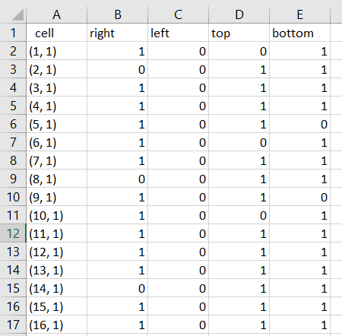

*Figure 1: excel.csv*

- And this is the code that can read the data from excel.csv

def upload\_map(self, loadMaze):

        with open(loadMaze, 'r') as f:

            last = list(f.readlines())[-1]

            c = last.split(',')

            c[0] = int(c[0].lstrip('"('))

            c[1] = int(c[1].rstrip(')"'))

            self.rows = c[0]

            self.cols = c[1]

            # self.grid = []

        with open(loadMaze, 'r') as f:

            r = csv.reader(f)

            next(r)

            for i in r:

                c = i[0].split(',')

                c[0] = int(c[0].lstrip('('))

                c[1] = int(c[1].rstrip(')'))

                self.maze\_map.append({'position': tuple(c),'right': int(i[1]), 'left': int(i[2]), 'top': int(i[3]), 'bottom': int(i[4])})

self.maze\_map\_run[tuple(c)]={'right':int(i[1]),'left':int(i[2]),'top':int(i[3]),'bottom':int(i[4])}

def draw\_walls(self, screen, cell\_size):

        wall\_color = (0, 0, 0)

        path\_color = (255, 0, 0)  # Color for the start position

        start\_position = (10, 10)  # Set the start position here

        for cell\_data in self.maze\_map:

            position = cell\_data['position']

            x, y = position[1] \* cell\_size, position[0] \* cell\_size

            if cell\_data['top'] == 0:

                pygame.draw.line(screen, wall\_color, (x, y), (x + cell\_size, y), self.thickness)

            if cell\_data['right'] == 0:

                pygame.draw.line(screen, wall\_color, (x + cell\_size, y), (x + cell\_size, y + cell\_size), self.thickness)

            if cell\_data['bottom'] == 0:

                pygame.draw.line(screen, wall\_color, (x, y + cell\_size), (x + cell\_size, y + cell\_size), self.thickness)

            if cell\_data['left'] == 0:

                pygame.draw.line(screen, wall\_color, (x, y), (x, y + cell\_size), self.thickness)

            if position == start\_position:

                pygame.draw.rect(screen, path\_color, (x, y, cell\_size, cell\_size), self.thickness)

        if start\_position == self.get\_last\_position():

pygame.draw.rect(screen, path\_color, (x, y, cell\_size, cell\_size), self.thickness)

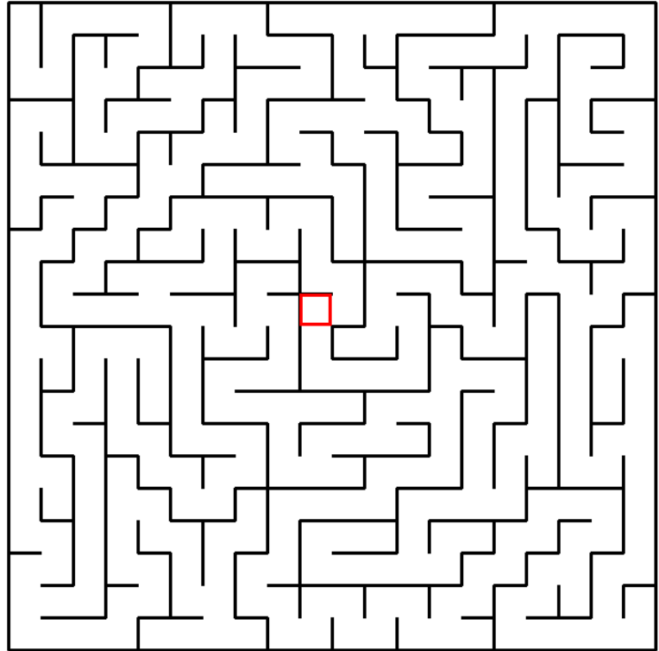

*Figure 2: Interface for maze*

**4.2.2 Create Map**

Just simple like a square with the color that we can set it

    self.player\_size = 30

    self.rect = pygame.Rect(self.x, self.y, self.player\_size, self.player\_size)

def draw(self, screen, color):

pygame.draw.rect(screen, color , self.rect)

**4.2.3 Create a goal position**

- Since the maze has 4 goals, we randomly chose to make it more interesting with 4 gates arranged in the 4 corners of the matrix.

    def get\_goal\_position\_random(self):

        last\_position = None  # Initialize with a default value

        r = randint(1, 4)  # Fix: Use randint instead of random and correct the range

        if r == 1:

            last\_position = (1, 1)

        elif r == 2:

            last\_position = (1, 20)

        elif r == 3:

            last\_position = (20, 1)

        elif r == 4:

            last\_position = (20, 20)

        return last\_position

**4.3 Algorithm**

**4.3.1 BFS Algorithm**

**4.3.1.1 Idea**

With unweighted graph and source vertex s. This graph can be directed or undirected, it does not matter to the algorithm.

The algorithm can be understood as a fire spreading on the graph: At step 0, only source vertex s is burning.

At each subsequent step, the fire burning at each vertex spreads to all adjacent vertices.

In each iteration of the algorithm, the "ring of fire" spreads out in width. The peaks closer to s will burn up first.

More precisely, the algorithm can be described as follows:

First we visit the source vertex s.

Visiting vertex s will generate the order of visiting vertices (u1, u2,...up) adjacent to s (the vertices closest to s). Next, we visit vertex u1. When we visit vertex u1, we will again be asked to visit vertices (v1, v2, ..., vp) adjacent to u1. But clearly these v vertices are "further" from s than uu vertices, so they can only be visited when all uu vertices have been visited. That is, the order of visiting vertices will be: s, u1, u2, …, up, v1, v2, …, vp.

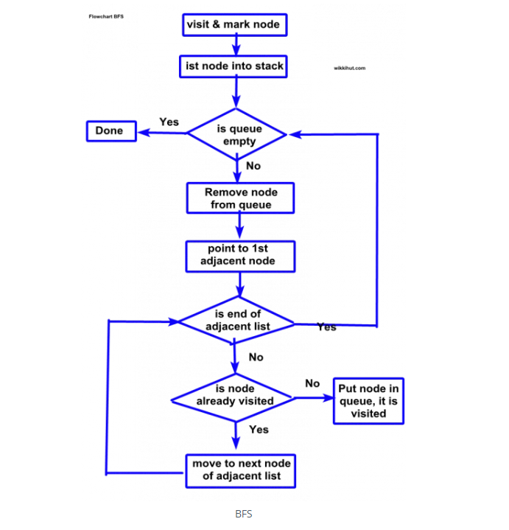

*Figure 3: Flowchart of BFS algorithm*

**4.3.1.2 Description in Python**

from maze import Maze

import pygame

import time

from collections import deque

class BFSSolver:

    def BFS(m, goal\_position):

        start = (10, 10)

        # start = goal\_position

        frontier = deque()

        frontier.append(start)

        bfsPath = {}

        visited\_nodes = 0

        explored = [start]

        bSearch = []

        start\_time = time.time()

        while len(frontier) > 0:

            currCell = frontier.popleft()

            visited\_nodes += 1

            if currCell == goal\_position:

                break

            for d in ['right', 'bottom', 'top', 'left']:

                if m.maze\_map\_run[currCell][d] == True:

                    if d == 'right':

                        childCell = (currCell[0], currCell[1] + 1)

                    elif d == 'left':

                        childCell = (currCell[0], currCell[1] - 1)

                    elif d == 'top':

                        childCell = (currCell[0] - 1, currCell[1])

                    elif d == 'bottom':

                        childCell = (currCell[0] + 1, currCell[1])

                    if childCell in explored:

                        continue

                    frontier.append(childCell)

                    explored.append(childCell)

                    bfsPath[childCell] = currCell

                    bSearch.append(childCell)

        end\_time = time.time()

        execution\_time = end\_time - start\_time

        fwdPath = {}

        cell = goal\_position

        fwdPath[bfsPath[cell]] = cell

        while cell != (10, 10):

            fwdPath[bfsPath[cell]] = cell

            cell = bfsPath[cell]

        result\_list = list(fwdPath.values())

        result\_list = list(reversed(result\_list))

        return result\_list, fwdPath, bSearch, visited\_nodes, execution\_time

**4.3.2 DFS Algorithm**

**4.3.2.1 Idea**

Depth-First Search (DFS) is an algorithm that explores a graph by going as deep as possible along each branch before backtracking. It traverses a graph or tree in a depthward motion and uses a stack to remember which vertices to visit next. DFS does not use a heuristic evaluation; instead, it systematically explores the graph without considering the distances or costs associated with the edges.

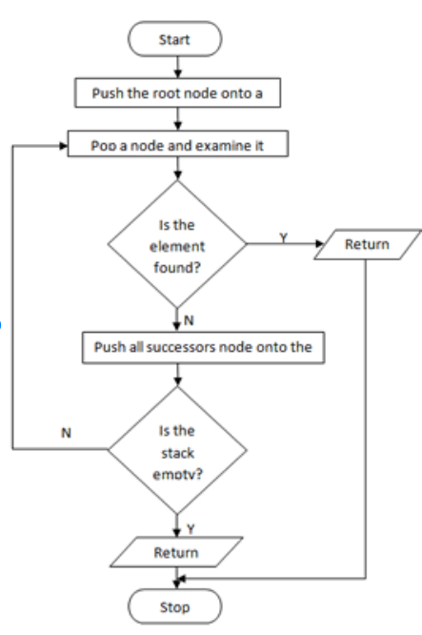

*Figure 4: Flowchart of BFS algorithm*

**4.3.2.2 Description in Python**

DFS starts at the initial node and explores as far as possible along each branch before backtracking. It can be implemented using recursion or an explicit stack.

from queue import LifoQueue

import pygame

from maze import Maze

import time

class DFSSolver:

    def DFS(m,goal\_position):

        start=(10,10)

        explored=[start]

        frontier=[start]

        dfsPath={}

        dSeacrh=[]

        visited\_nodes =0

        start\_time = time.time()

        while len(frontier)>0:

            currCell=frontier.pop()

            visited\_nodes += 1

            dSeacrh.append(currCell)

            if currCell==goal\_position:

                break

            poss=0

            for d in ['right', 'left', 'top', 'bottom']:

                if m.maze\_map\_run[currCell][d] == 1:

                    if d == 'right':

                        child = (currCell[0], currCell[1] + 1)

                    elif d == 'left':

                        child = (currCell[0], currCell[1] - 1)

                    elif d == 'top':

                        child = (currCell[0] - 1, currCell[1])

                    elif d == 'bottom':

                        child = (currCell[0] + 1, currCell[1])

                    if child in explored:

                        continue

                    explored.append(child)

                    frontier.append(child)

                    dfsPath[child]=currCell

        end\_time = time.time()

        execution\_time = end\_time - start\_time

        fwdPath={}

        cell=goal\_position

        while cell!=start:

            fwdPath[dfsPath[cell]]=cell

            cell=dfsPath[cell]

        result\_list = list(fwdPath.values())

        result\_list = list(reversed(result\_list))

        return result\_list,fwdPath,dSeacrh, visited\_nodes, execution\_time

**4.3.3 A\* Algorithm**

**4.3.3.1 Idea**

This algorithm finds a path from a start node to a given destination node (or to a node that satisfies a destination condition). This algorithm uses a "heuristic evaluation" to rank each node according to its estimate of the best route through that node. This algorithm traverses the nodes in the order of this heuristic evaluation. Therefore, the A\* algorithm is an example of best-first search.

**4.3.3.2 Description in Python**

A\* stores a set of incomplete solutions, that is, paths through the graph, starting from the starting node. This solution set is stored in a priority queue. The priority order is decided by the Heuristic function f(x) = g(x) +h(x)

In this problem, h(x) is the distance from the current node to the destination node g(x) is the distance calculated as the crow flies from the current node to the node to be considered f(x) = g(x)+ h(x)

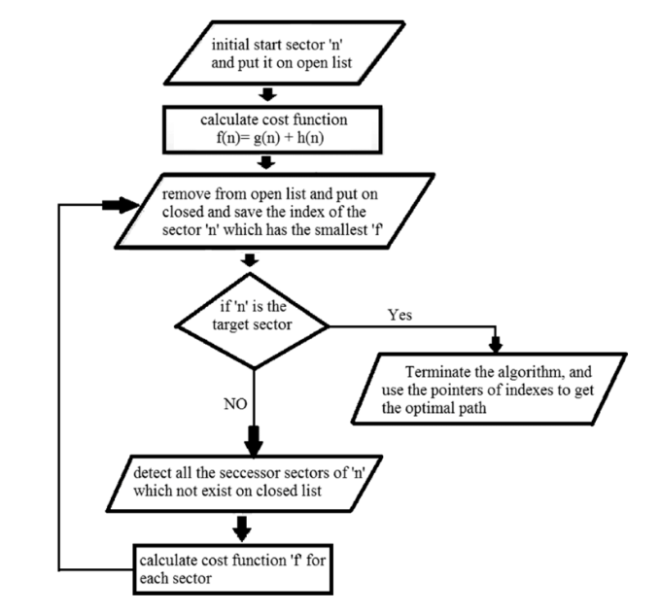

*Figure 5: Flowchart of BFS algorithm*

from queue import PriorityQueue

import pygame

from maze import Maze

import time

class AStarSolver:

    def h(cell1, cell2):

        x1, y1 = cell1

        x2, y2 = cell2

        return abs(x1 - x2) + abs(y1 - y2)

    def aStar(m,goal\_position):

        # start = (10,10)

        start = (10,10)

        open = PriorityQueue()

        open.put((AStarSolver.h(start, goal\_position), AStarSolver.h(start, goal\_position), start))

        aPath = {}

        g\_score = {cell: float('inf') for cell in m.maze\_map\_run}

        g\_score[start] = 0

        f\_score = {cell: float('inf') for cell in m.maze\_map\_run}

        f\_score[start] = AStarSolver.h(start, goal\_position)

        searchPath=[start]

        visited\_nodes = 0

        start\_time = time.time()

        while not open.empty():

            currCell = open.get()[2]

            visited\_nodes += 1  # Increment the visited nodes counter

            searchPath.append(currCell)

            if currCell == goal\_position:

                break

            for d in ['right', 'bottom', 'top', 'left']:

                if m.maze\_map\_run[currCell][d]==True:

                    if d=='right':

                        childCell=(currCell[0],currCell[1]+1)

                    elif d=='left':

                        childCell=(currCell[0],currCell[1]-1)

                    elif d=='top':

                        childCell=(currCell[0]-1,currCell[1])

                    elif d=='bottom':

                        childCell=(currCell[0]+1,currCell[1])

                    temp\_g\_score = g\_score[currCell] + 1

                    temp\_f\_score = temp\_g\_score + AStarSolver.h(childCell, goal\_position)

                    if temp\_f\_score < f\_score[childCell]:

                        g\_score[childCell] = temp\_g\_score

                        f\_score[childCell] = temp\_g\_score + AStarSolver.h(childCell, goal\_position)

                        open.put((f\_score[childCell], AStarSolver.h(childCell, goal\_position), childCell))

                        aPath[childCell] = currCell

        end\_time = time.time()

        execution\_time = end\_time - start\_time

        fwdPath={}

        cell=goal\_position

        while cell!=start:

            fwdPath[aPath[cell]]=cell

            cell=aPath[cell]

        result\_list = list(fwdPath.values())

        result\_list = list(reversed(result\_list))

        print("Visited Nodes:", visited\_nodes)  # Print the visited nodes count

        return result\_list,fwdPath,searchPath,visited\_nodes, execution\_time

**4.3.4 Greedy Best-First Search Algorithm**

**4.3.4.1 Idea**

The GBFS algorithm will evaluate the vertices using the heuristic function h(n), meaning the evaluation function will be equal to the heuristic function f(n) = h(n). This makes the algorithm ‘greedy’.

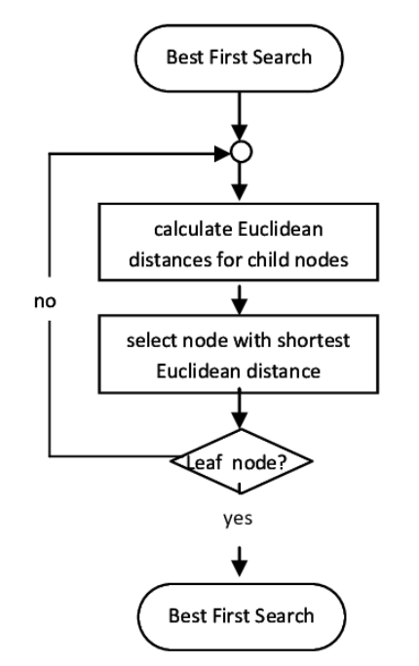

*Figure 6: Flowchart of BFS algorithm*

**4.3.4.2 Description in Python**

The Greedy Best-First Search algorithm will use an evaluation function, the heuristic function h(n).

This heuristic function h(n) will evaluate the cost to go from current node n to destination node

from queue import PriorityQueue

import pygame

from maze import Maze

import time

class GreedySolver:

    def h(cell, goal\_position):

        x, y = cell

        goal\_x, goal\_y = goal\_position

        return abs(x - goal\_x) + abs(y - goal\_y)

    def greedy(m, goal\_position):

        start = (10,10)

        open = PriorityQueue()

        open.put((GreedySolver.h(start, goal\_position), start))

        aPath = {}

        searchPath = [start]

        visited\_nodes = 0

        start\_time = time.time()

        while not open.empty():

            \_, currCell = open.get()

            visited\_nodes += 1  # Increment the visited nodes counter

            searchPath.append(currCell)

            if currCell == goal\_position:

                break

            for d in ['right', 'bottom', 'top', 'left']:

                if m.maze\_map\_run[currCell][d]:

                    if d == 'right':

                        childCell = (currCell[0], currCell[1] + 1)

                    elif d == 'left':

                        childCell = (currCell[0], currCell[1] - 1)

                    elif d == 'top':

                        childCell = (currCell[0] - 1, currCell[1])

                    elif d == 'bottom':

                        childCell = (currCell[0] + 1, currCell[1])

                    if childCell not in aPath:

                        open.put((GreedySolver.h(childCell, goal\_position), childCell))

                        aPath[childCell] = currCell

        end\_time = time.time()

        execution\_time = end\_time - start\_time

        fwdPath = {}

        cell = goal\_position

        while cell != start:

            fwdPath[aPath[cell]] = cell

            cell = aPath[cell]

        result\_list = list(fwdPath.values())

        result\_list = list(reversed(result\_list))

        return result\_list, fwdPath, searchPath, visited\_nodes, execution\_time

**4.3.5 Dijkstra's Algorithm**

**4.3.5.1 Idea**

Dijkstra's algorithm is used to find the shortest path from a source vertex s to all other vertices in a graph with non-negative edge weights. It maintains a set of vertices whose shortest distance from the source is known and continually expands this set until all vertices are included.

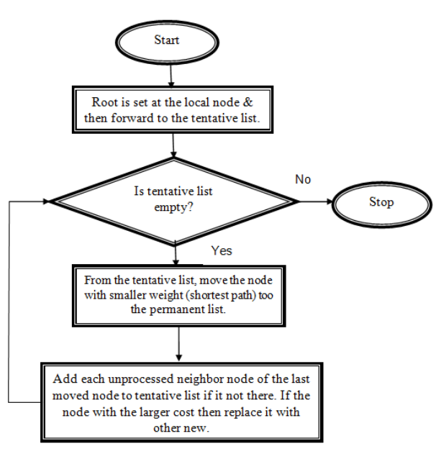

*Figure 7: Flowchart of Dijkstra algorithm*

**4.3.5.2 Description in Python**

from queue import PriorityQueue

import pygame

from maze import Maze

import time

class DijkstraSolver:

    def dijkstra(m,goal\_position):

        start =(10,10)

        open = PriorityQueue()

        open.put((0, start))

        dist = {cell: float('inf') for cell in m.maze\_map\_run}

        dist[start] = 0

        aPath = {}

        searchPath = [start]

        visited\_nodes = 0  # Counter for visited nodes

        start\_time = time.time()

        while not open.empty():

            currCost, currCell = open.get()

            visited\_nodes += 1  # Increment the visited nodes counter

            searchPath.append(currCell)

            if currCell == goal\_position:

                break

            for d in ['right', 'bottom', 'top', 'left']:

                if m.maze\_map\_run[currCell][d]:

                    if d == 'right':

                        childCell = (currCell[0], currCell[1] + 1)

                    elif d == 'left':

                        childCell = (currCell[0], currCell[1] - 1)

                    elif d == 'top':

                        childCell = (currCell[0] - 1, currCell[1])

                    elif d == 'bottom':

                        childCell = (currCell[0] + 1, currCell[1])

                    edgeCost = 1  # Assuming each step has a cost of 1

                    if dist[currCell] + edgeCost < dist[childCell]:

                        dist[childCell] = dist[currCell] + edgeCost

                        open.put((dist[childCell], childCell))

                        aPath[childCell] = currCell

        end\_time = time.time()

        execution\_time = end\_time - start\_time

        fwdPath = {}

        cell = goal\_position

        while cell != start:

            fwdPath[aPath[cell]] = cell

            cell = aPath[cell]

        result\_list = list(fwdPath.values())

        result\_list = list(reversed(result\_list))

        # print("Visited Nodes:", visited\_nodes)  # Print the visited nodes count

        return result\_list, fwdPath, searchPath,visited\_nodes, execution\_time

1. **FUNCTION.**

**5.1 Player function**

|  |
| --- |
| def check\_move(self, tile,maze\_map\_run ,thickness):          current\_cell\_x, current\_cell\_y = self.y // tile, self.x // tile          current\_cell\_abs\_x, current\_cell\_abs\_y = current\_cell\_y \* tile, current\_cell\_x \* tile            print("Player:", self.y, self.x)          print("Current Cell:", current\_cell\_x, current\_cell\_y)            if self.left\_pressed:              print("Checking Left:", maze\_map\_run[current\_cell\_x, current\_cell\_y]['left'])              if maze\_map\_run[current\_cell\_x,current\_cell\_y]['left'] == 0:                      self.left\_pressed = False          if self.right\_pressed:              print("Checking Right:", maze\_map\_run[current\_cell\_x, current\_cell\_y]['right'])              if maze\_map\_run[current\_cell\_x,current\_cell\_y]['right'] == 0:                      self.right\_pressed = False          if self.up\_pressed:              print("Checking Top:", maze\_map\_run[current\_cell\_x, current\_cell\_y]['top'])                if maze\_map\_run[current\_cell\_x,current\_cell\_y]['top'] == 0:                      self.up\_pressed = False          if self.down\_pressed:              print("Checking Bottom:", maze\_map\_run[current\_cell\_x, current\_cell\_y]['bottom'])              if maze\_map\_run[current\_cell\_x,current\_cell\_y]['bottom'] == 0:                      self.down\_pressed = False |

**5.2 Bot function**

|  |
| --- |
| if 800 <= mouse\_x <= 800 + 100 and \             170 <= mouse\_y <= 170 + 50:    clock.start\_timer()          player = Player(30\*10,30\*10)          player1 = Player(30\*10,30\*10)          dfs\_path, dfs\_fwdPath, dfsSearch, visited\_nodes, execution\_time  = DFSSolver.DFS(maze, self.goal\_position)          font = pygame.font.Font(None, 36)          text1 = font.render(f'Visited Nodes: {visited\_nodes}', True, (0, 0, 0))          screen.blit(text1, (50,650))          text2 = font.render(f'Time: {execution\_time\*1000}', True, (0, 0, 0))          screen.blit(text2, (50,670))             for step in dfsSearch:              player1.follow\_searchPath([step], self.screen)                 self.\_draw(maze, tile, player1, game, clock,self.color\_blue)              pygame.time.delay(10)                 self.screen.fill(pygame.Color("darkslategray"), (650, 0, 752, 752))              for step in dfs\_fwdPath:                player.follow\_searchPath([step], self.screen)              self.\_draw(maze, tile, player, game, clock,self.color\_green)              pygame.time.delay(100)                  self.screen.fill(pygame.Color("darkslategray"), (650, 0, 752, 752))              for step in dfs\_path:                  if game.is\_game\_over(player,self.goal\_position):                  self.game\_over = True                  else:                      self.game\_over = False                      player.follow\_searchPath([step], self.screen)                  self.\_draw(maze, tile, player, game, clock,self.color\_red)                      pygame.time.delay(100)                      self.screen.fill(pygame.Color("darkslategray"), (650, 0, 752, 752))                  self.game\_over = True            print('DFS') |

**5.3 Bot vs Bot**

|  |
| --- |
| if 660 <= mouse\_x <= 660 + 100 and \          460 <= mouse\_y <= 460 + 50:      clock.start\_timer()      self.goal\_position2 = self.get\_goal\_position\_random()      while (self.goal\_position2 == self.goal\_position):          self.goal\_position2 = self.get\_goal\_position\_random()      player2 = Player(30\*10,30\*10)      greedy\_path, greedy\_fwdPath, GreedySearch,visited\_nodes, execution\_time  = GreedySolver.greedy(maze, self.goal\_position)      greedy\_path2, greedy\_fwdPath2, GreedySearch2,visited\_nodes2, execution\_time2 = GreedySolver.greedy(maze, self.goal\_position2)      for step, step2 in zip(greedy\_path, greedy\_path2):          player.follow\_path([step], self.screen)          player2.follow\_path([step2], self.screen)          self.\_drawTwoPlayer(maze, tile, player,player2, game, clock,self.color\_green,self.color\_blue)          pygame.time.delay(200)          self.screen.fill(pygame.Color("darkslategray"), (650, 0, 752, 752))            if game.is\_game\_over(player,self.goal\_position) :              self.game\_over = True          elif game.is\_game\_over(player2,self.goal\_position2) :              self.winner = 1              self.game\_over = True          else:              self.game\_over = False  print('Two bot') |

**5.4 Player vs Player**

|  |
| --- |
| def \_drawTwoPlayer(self, maze, tile, player,player2, game, clock, color, color2):          # draw maze          maze.draw\_walls(screen, tile)          # add a goal point to reach1111          game.add\_goal\_point(self.screen,self.goal\_position)          if(self.goal\_position2 != None):              game.add\_goal\_point(self.screen,self.goal\_position2)          # draw every player movement          player.draw(self.screen,color)          player.update()            player2.draw(self.screen,color2)          player2.update()            # instructions, clock, winning message          self.instructions()          if self.game\_over:              if self.winner == 0:                  clock.stop\_timer()                  self.screen.blit(game.message(),(660,520))              elif self.winner == 1:                  clock.stop\_timer()                  self.screen.blit(game.message2(),(660,520))          else:              clock.update\_timer()          self.screen.blit(clock.display\_timer(), (710,550))            pygame.display.flip() |

|  |
| --- |
| if 660 <= mouse\_x <= 660 + 100 and \                              400 <= mouse\_y <= 400 + 50:                          clock.start\_timer()                          player2 = Player(30\*11,30\*11)                          print('Two player') |

|  |
| --- |
| if(player2 == None):                  self.\_draw(maze,tile,player,game,clock,self.color\_green)              else:                  self.\_drawTwoPlayer(maze ,tile,player,player2 ,game, clock, self.color\_green, self.color\_blue) |

1. **EXPERIMENT, ANALYZE, EVALUATE RESULTS.**

**6.1 Interface information**

**6.1.1. Interface when starting the game**

**-** When we start the game, the interface will appear like Figure 1 to start the game.

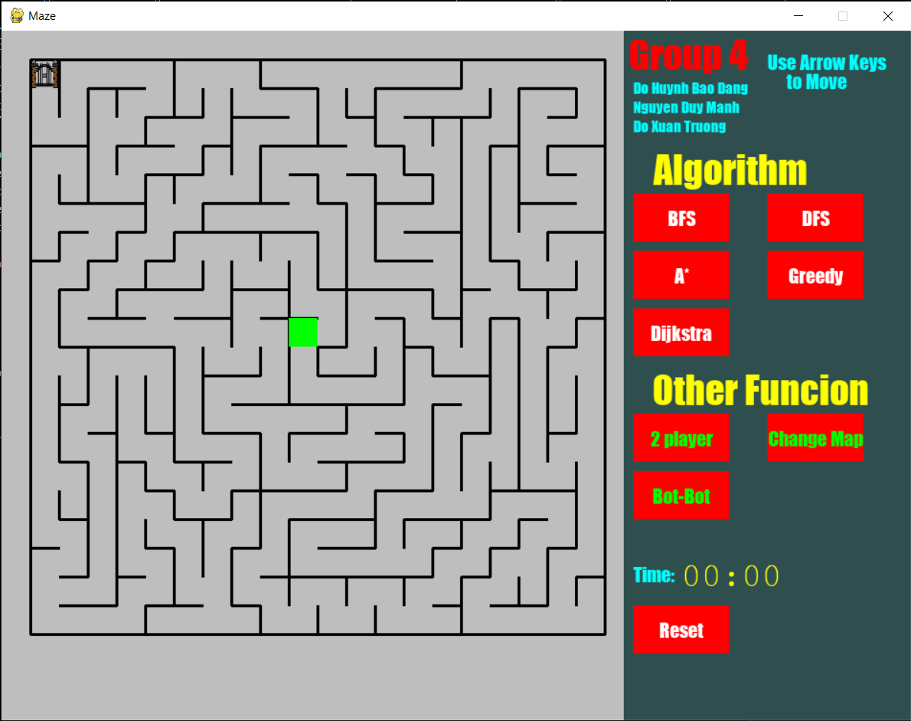

*Figure 8: Interface when starting the game*

**6.1.2. Interface 4 goals and 3 mazes**

- To change the goal, before starting the game we can select "Reset". Here we have 4 goals for the bot to reach

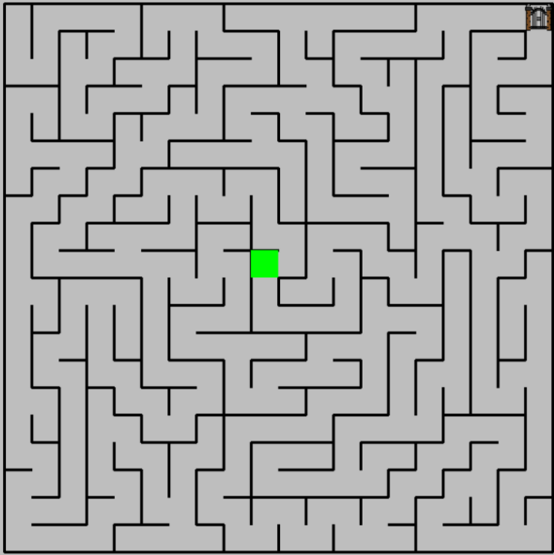 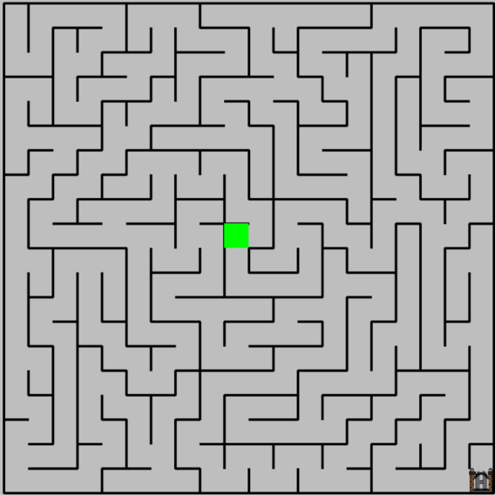

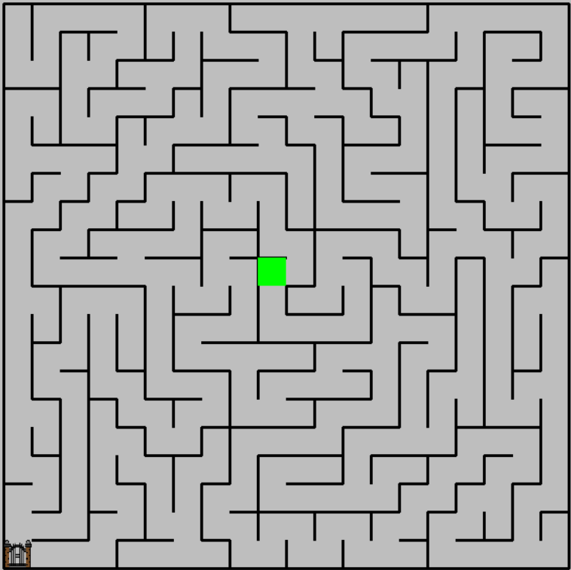 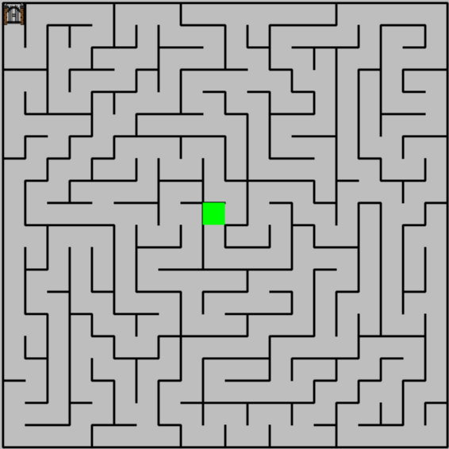

*Figure 9: Interface for 4 goals*

- To change the maze, before starting the game we can select "Change Map". Here we have 3 mazes for the user can choose.

 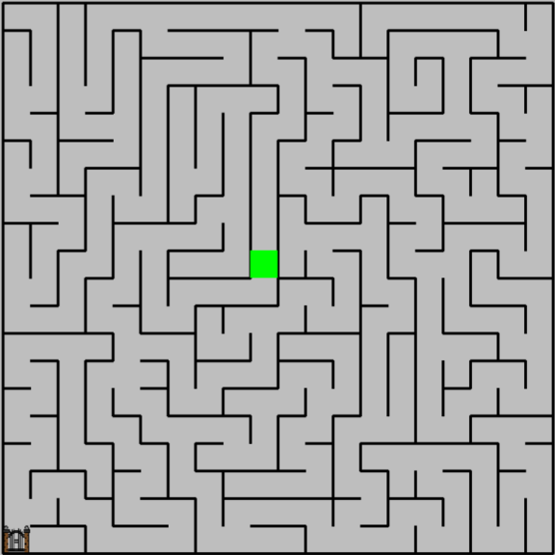

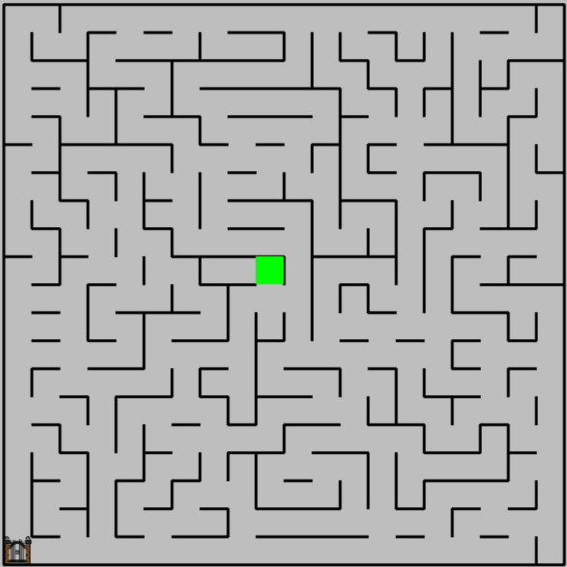

*Figure 10: Interface for 3 mazes*

**6.1.3. Start Node (Player)**

- To control the starting node, we use keycodes (W, S, A, D, UpArrow, DownArrow, LeftArrow, RightArrow)

- W, UpArrow to move the character to the top of

- S, DownArrow to move the character to the bottom of

- A, LeftArrow to move the character to the left

- D, RightArrow to move the character to the right

**6.1.4. Start Node (Bot)**

- For the bot to start running, we can click directly on the algorithms available on the game menu:

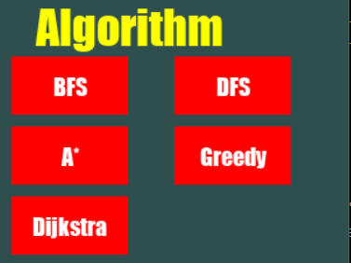 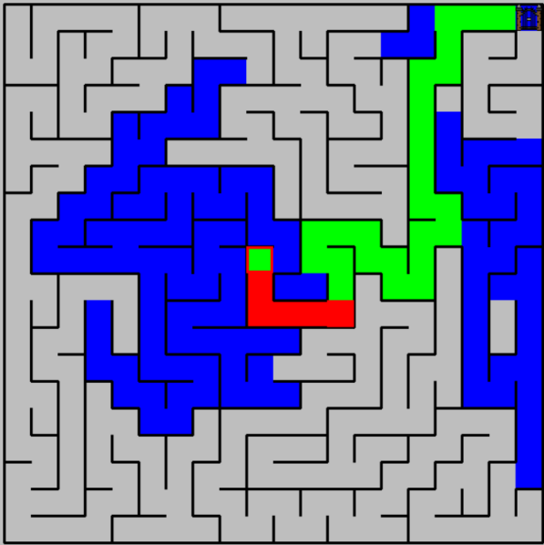

*Figure 11: Interface for running bot*

**6.1.5. Game mode**

- We have 2 game modes for 2:

+ Player vs player: In this mode, two players will use the keyboard to move and reach a destination, whoever comes first will be the winner.

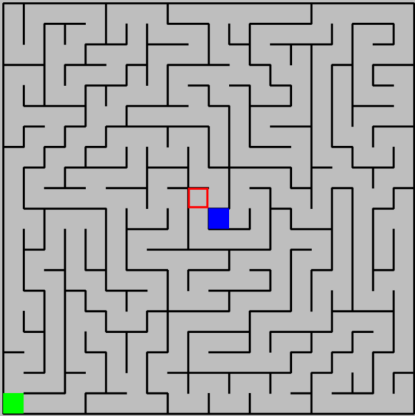 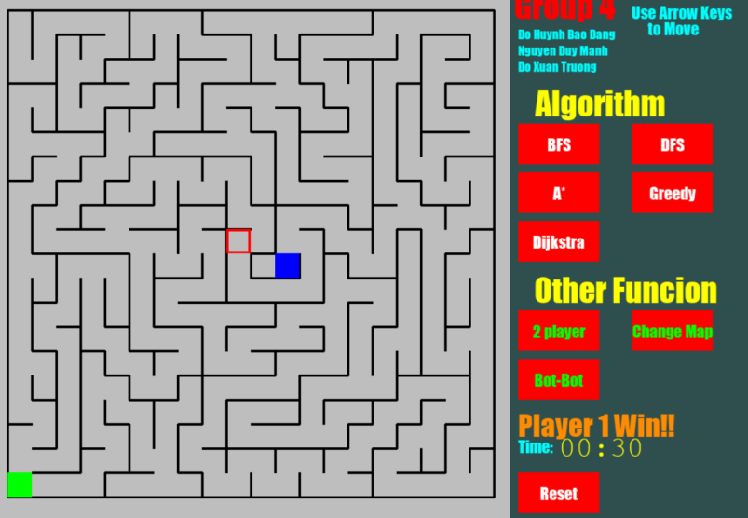

*Figure 12: Interface for 2 players*

+ Bot vs bot: In this mode, there will be a little difference, two bots will move to any 2 different gates, if the bot reaches the gate the fastest, it will win.

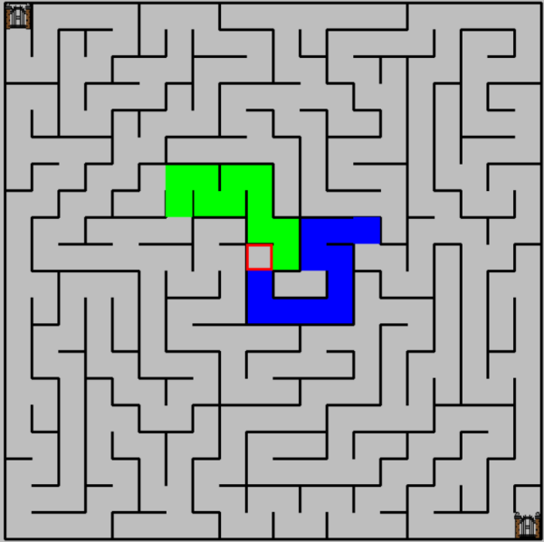

*Figure 13: Interface for two bots*

**6.2. Analyze, experiment, evaluate**

To distinguish between algorithms, find the most optimal solution using an algorithm based on different cases of a matrix. Here we use the same matrix in applying the 5 algorithms and create a summary table to compare and draw conclusions about the above algorithms.

**6.2.1.** **Analyze, experiment**

**6.2.1.1. Maze one.**

**a, BFS**

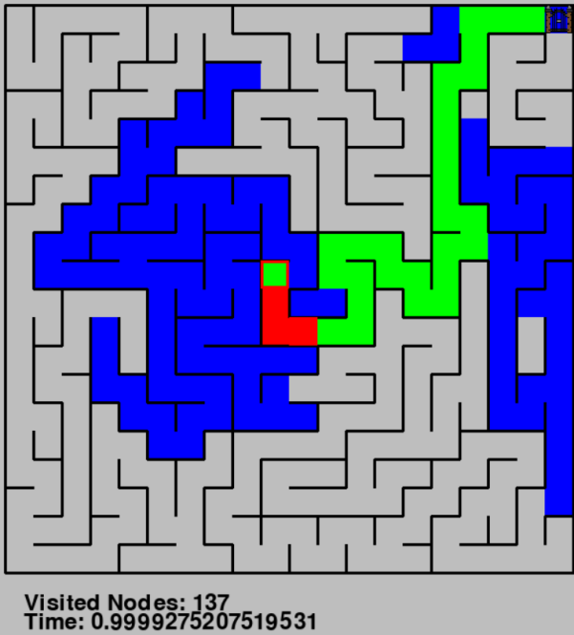

*Figure 14: Interface for BFS*

**b, DFS**

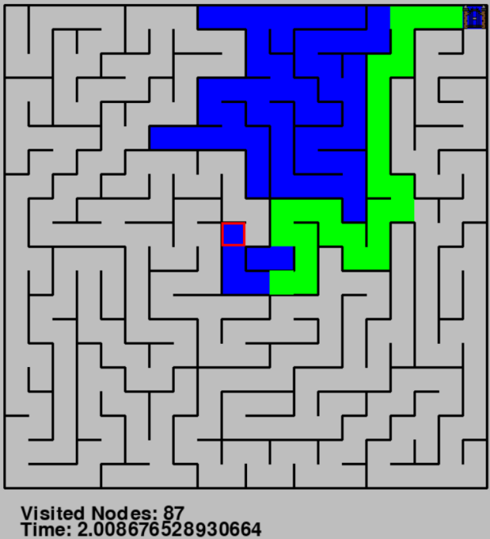

*Figure 15: Interface for DFS*

**c, A\***

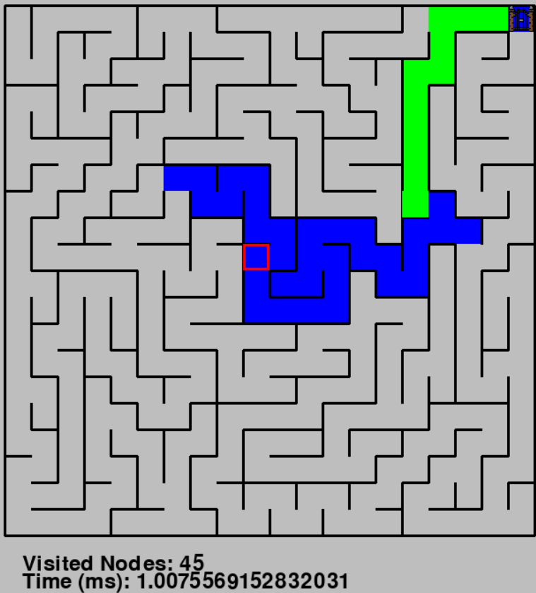

*Figure 16: Interface for A Star*

**d, GBFS**

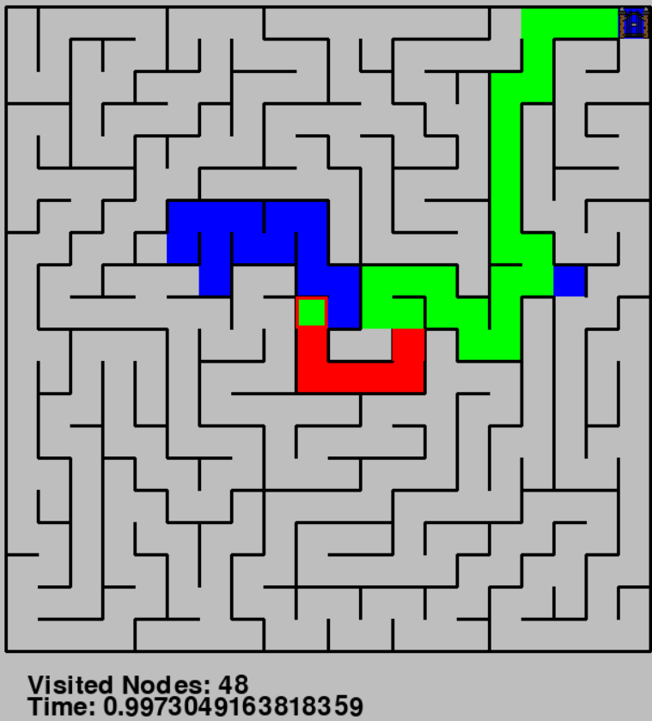

*Figure 17: Interface for GBFS*

**e, Dijkistra’s**

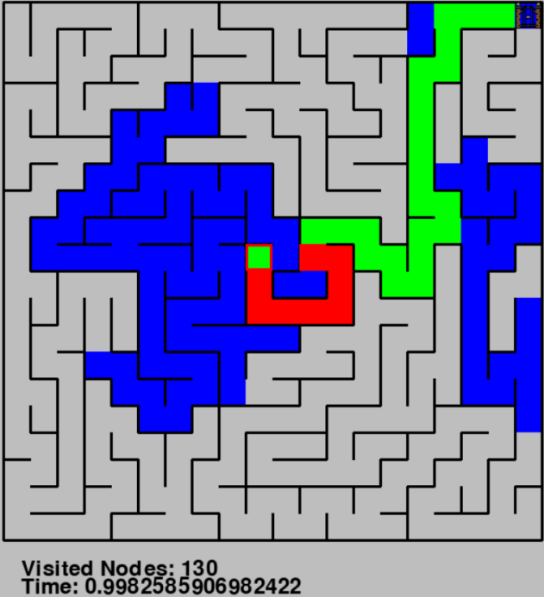

*Figure 18: Interface for Dijkistra*

**6.3. Summary table**

|  |  |  |
| --- | --- | --- |
| Statistical value | Visited Node | Execution Time |
| Algorithm |
| BFS | 137 | 0.999 ms |
| DFS | 87 | 2.008 ms |
| A Star | 45 | 1.008 ms |
| GBFS | 48 | 0.997 ms |
| Dijkistra | 130 | 0.998 ms |

From the experimental analysis table obtained, we see:

- BFS (Breadth-First Search):

Visited Nodes: 137 - Out of the number of visited nodes, BFS can often visit more nodes than other algorithms, especially on large graphs or complex mazes.

Execution Time: 0.999 ms - Execution time is relatively fast, but sometimes BFS can take significant time if the graph is too large.

- DFS (Depth-First Search):

Visited Node: 87 - DFS typically has a lower number of visited nodes than BFS. It can take advantage of its "deep first, then broad" nature.

Execution Time: 2,008 ms - Higher execution time compared to BFS. DFS can get stuck in deep paths and thus take longer to complete.

- A Star:

Visited Node: 45 - A Star typically helps reduce the number of visited nodes by combining actual costs and estimated costs (heuristics).

Execution Time: 1,008 ms - Relatively fast execution time. A Star is often effective when it has a good heuristic function.

- GBFS (Greedy Best-First Search):

Visited Node: 48 - GBFS uses a "greedy" strategy, focusing on heuristic cost estimates to decide scaling steps.

Execution Time: 0.997 ms - Relatively fast execution time. GBFS may choose a suboptimal path if the heuristic function is incorrect.

- Dijkstra:

Visited Node: 130 - Dijkstra visits a larger number of nodes than A Star, because it does not use heuristics.

Execution Time: 0.998 ms - Relatively fast execution time. Dijkstra guarantees finding the shortest path on a graph with non-negative weights.

1. **CONCLUSION.**

**7.1** **Assessments:**

From analyzing, evaluating, and testing our group, we realized BFS is the foundation algorithm for the development of other algorithms such as AStar and GBFS . With a simple small map, algorithms can almost always find the shortest path. The most optimal in terms of time and distance is still GBFS and if the maze game is weighted and complex, AStar may be more optimal when applying its calculation function to find the algorithm.

**7.2 Development:**

We will develop many different game modes such as player vs computer, develop the user interface, add many new functions such as applying weights to maze games,...

**7.3 Experience learned:**

**-** Learn python language

- Algorithm selection depends on specific requirements

- Space and time complexity are important factors

- Advantages and limitations of each algorithm

- The importance of modeling

- Understand the goals and characteristics of the game

1. **REFERENCES.**
   1. [How to Make a Maze Game in Python - Python Code (thepythoncode.com)](https://thepythoncode.com/article/build-a-maze-game-in-python" \l "google_vignette)
   2. [A\* Search Algorithm - GeeksforGeeks](https://www.geeksforgeeks.org/a-search-algorithm/?ref=header_search)
   3. [Breadth First Search or BFS for a Graph - GeeksforGeeks](https://www.geeksforgeeks.org/breadth-first-search-or-bfs-for-a-graph/?ref=header_search)
   4. [Depth First Search or DFS for a Graph - GeeksforGeeks](https://www.geeksforgeeks.org/depth-first-search-or-dfs-for-a-graph/?ref=header_search)
   5. [C / C++ Program for Dijkstra's shortest path algorithm | Greedy Algo-7 - GeeksforGeeks](https://www.geeksforgeeks.org/c-program-for-dijkstras-shortest-path-algorithm-greedy-algo-7/?ref=header_elastic)
   6. [Greedy Best first search algorithm - GeeksforGeeks](https://www.geeksforgeeks.org/greedy-best-first-search-algorithm/?ref=header_search)